Transmitter
# Source: Chatgpt (GPT-5-Mini) at [1/23/2026]
A transmitter is a device that converts information into radio waves and sends it through the air using an antenna. It is a key part of any wireless communication system, including radio, TV, Wi-Fi, mobile phones, and satellites.

📡 What Does a Transmitter Do?
# Source: Chatgpt (GPT-5-Mini) at [1/23/2026]
A transmitter takes data like:
- 📞 Voice (for phone calls)
- 📝 Text or Data (for internet)
- 🎵 Audio (for radio)
- 🎥 Video (for TV)
Then:
- Encodes the data (modulation).
- Generates a radio wave at a specific frequency.
- Combines the wave with the data (modulated signal).
- Sends it through the antenna into the air.

🔧 Key Components of a Transmitter:
# Source: Chatgpt (GPT-5-Mini) at [1/23/2026]
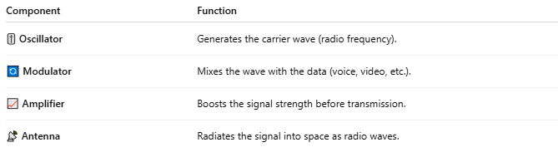

Component | Function
🎚️ Oscillator | Generates the carrier wave (radio frequency).
🔄 Modulator | Mixes the wave with the data (voice, video, etc.).
📈 Amplifier | Boosts the signal strength before transmission.
📡 Antenna | Radiates the signal into space as radio waves.

🧠 Example in Real Life:
# Source: Chatgpt (GPT-5-Mini) at [1/23/2026]
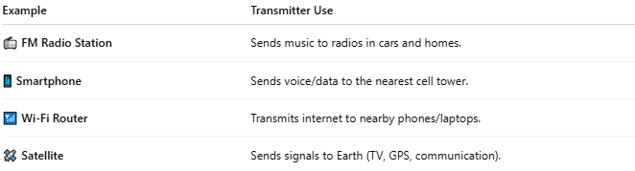

Example | Transmitter Use
📻 FM Radio Station | Sends music to radios in cars and homes.
📱 Smartphone | Sends voice/data to the nearest cell tower.
📶 Wi-Fi Router | Transmits internet to nearby phones/laptops.
🛰️ Satellite | Sends signals to Earth (TV, GPS, communication).

📖 Summary:
# Source: Chatgpt (GPT-5-Mini) at [1/23/2026]
A transmitter is a device that sends out information wirelessly by converting it into radio waves. It’s a core part of all wireless systems — from radio stations and phones to Wi-Fi and satellites.

